**Install Tool Box**

1. Download RTB10.4.mltbx from following link.

<https://petercorke.com/toolboxes/robotics-toolbox/>

1. Navigate to the “.mltbx” file from file explorer in matlab and then double click to install.

**Add Path**

1. Click on Set Path.

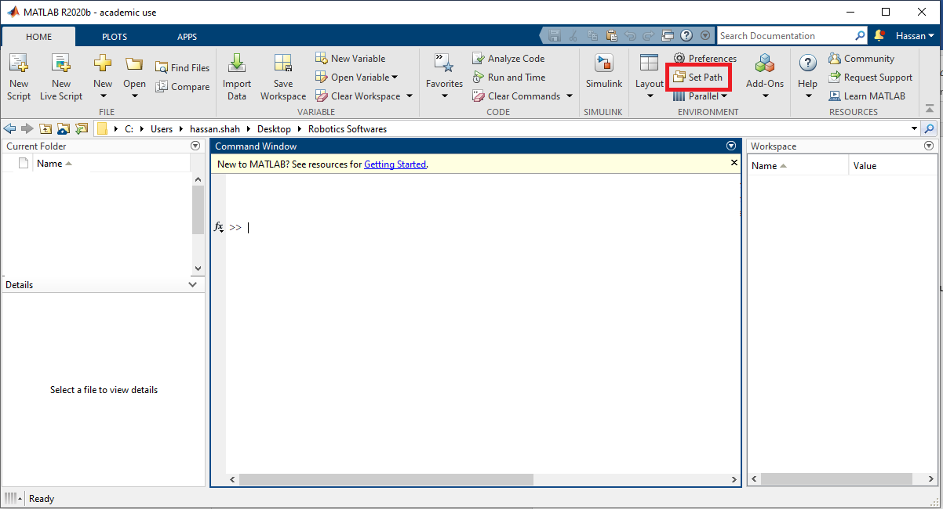

1. Click on Add with subfolder.

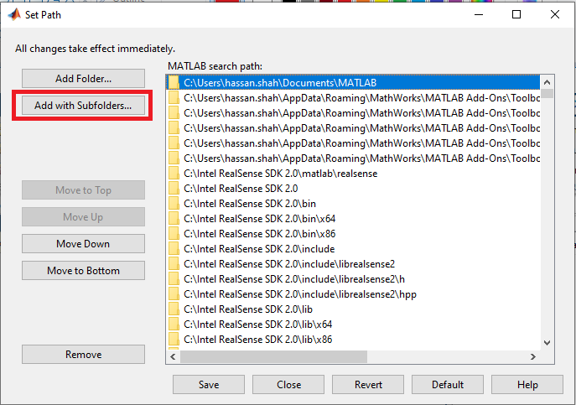

1. Navigate to Robotics Toolbox for Matlab/interfaces and click select folder.

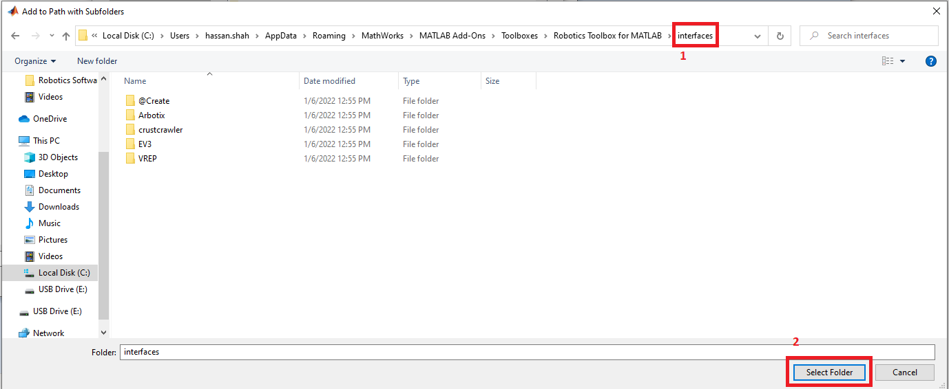

1. Path to 5 folders will be added, click save.

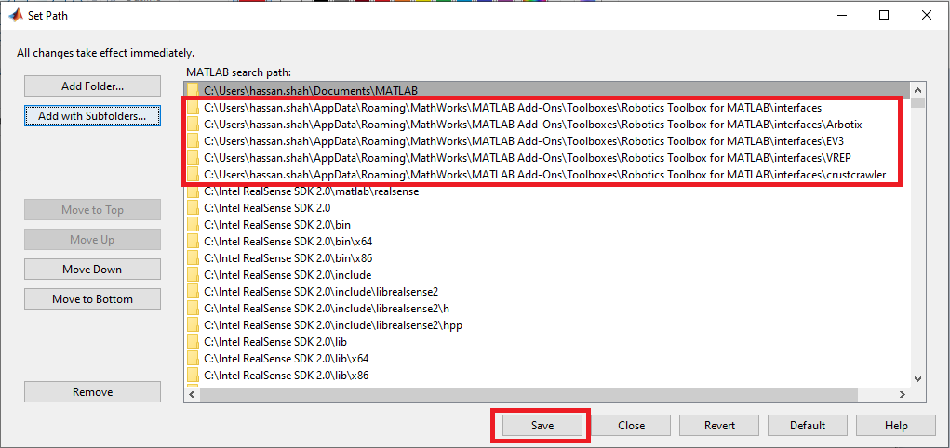

1. Download rtb_real_robot.pdf from following link.  
   <https://petercorke.com/matlab/interfacing-a-hobby-robot-arm-to-matlab/>

1. Follow heading 3.1 to test your robot.